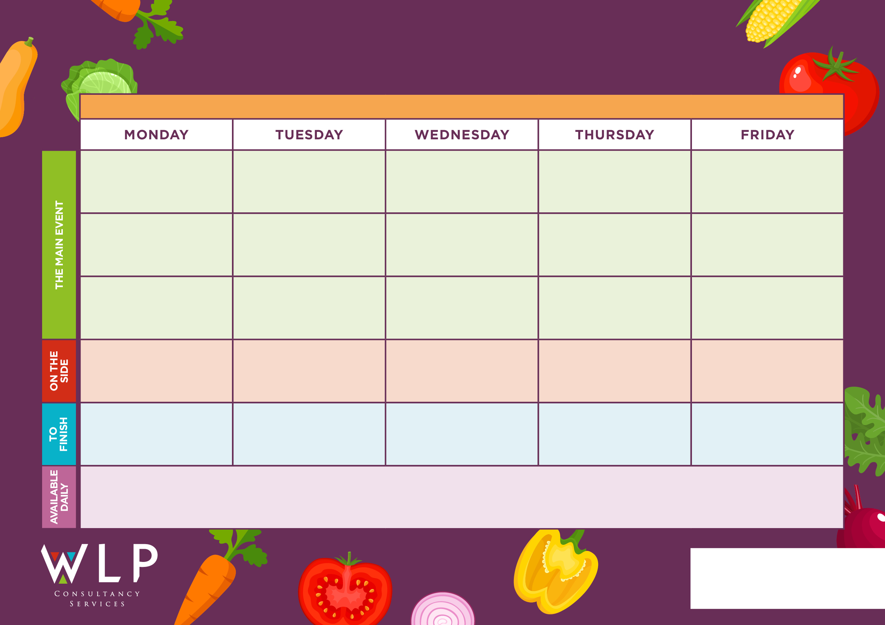
RUSHBURY CE PRIMARY SCHOOL WEEK 1 – w/c 13.4.2026, 4.5.2026, 25.5.2026 (H/Term), 15.6.2026, 6.7.2026
Roast & Creamed Potatoes, Cabbage, Carrots
Cheese & Potato Pie
R
Cauliflower Cheese
Battered Fillet of Fish
Macaroni Cheese
Baked Vegetarian Indian Selection
Seasonal Salad Selection & Fresh Bread

Seasonal Salad Selection & Fresh Bread
Seasonal Salad Selection & Fresh Bread

Seasonal Salad Selection& Fresh Bread

Jelly/Peaches
Iced Sprinkle Cake
Chocolate Crunch
Ice Cream & Fresh Fruit Salad
Fruit Pie & Custard
Vegetarian Sausage
Vegetable Curry & Boiled Rice
Traditional Roast with Rich &Tasty Gravy
Breaded Fishfingers
Seasonal Salad Selection & Fresh Bread
Pork Sausage with Rich Tasty Gravy
Chips, Couscous, Garden Peas, Baked Beans
Naan Bread, Mixed Vegetables, Green beans
Potato Wedges, Couscous, Sweetcorn, Broccoli

Creamed Potatoes, Garden Peas, Beans

Freshly made bread, salad and fresh fruit, assorted yoghurts, are readily available daily.
Additional vegetarian & vegan options are available daily.

