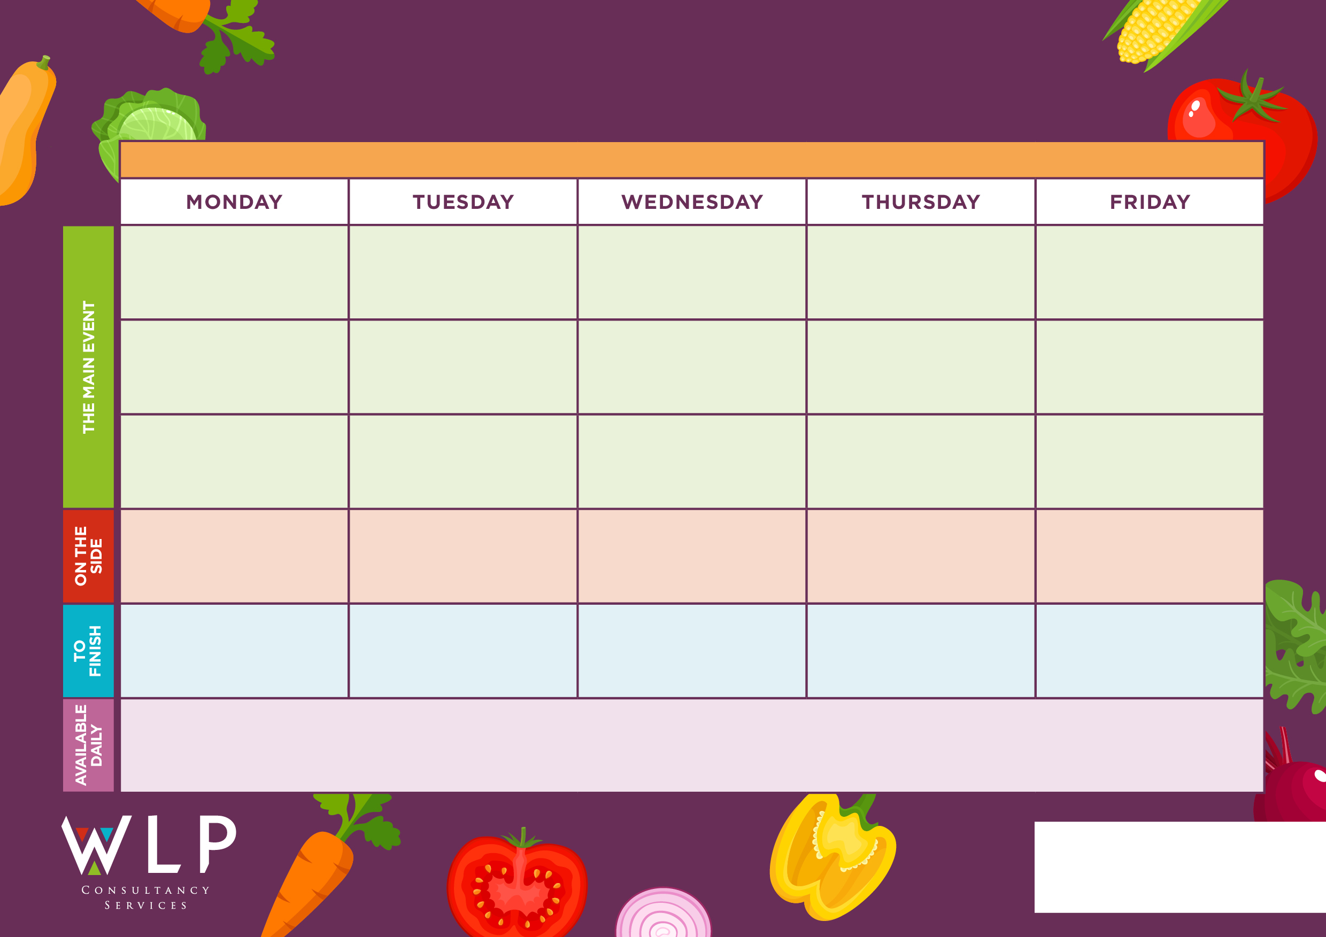
RUSHBURY CE PRIMARY SCHOOL WEEK 2 – W/C 20.4.2026, 11.5.2026, 1.6.2026, 22.6.2026, 13.7.2026
Seasonal Salad Selection & Fresh Bread

Mini Waffles, Garden Peas, Sliced Green Beans,

Seasonal Salad Selection & Fresh Bread

Vegetarian Burger
Seasonal Salad Selection & Fresh Bread

Seasonal Salad Selection & Fresh Bread


Pizza Selection Various Toppings
Battered Fillet of Fish
Cheesy Beans Wrap
Vegetarian Sausage
Seasonal Salad Selection & Fresh Bread

Shortbread
Vanilla Ice Cream
Flapjack
Apple Crumble & Custard
Angel Delight
Vegetable Nuggets
Beef Lasagne
Traditional Roast with Rich & Tasty Gravy
Handmade Beef /Cheese Burgers
Handmade Sausage Roll in Puff Pastry
Chips, Couscous, Garden Peas, Broccoli
Garlic Bread, Mixed Vegetables, Cauliflower
Roast & Creamed Potatoes, Carrots & Cabbage
Potao Wedges, Sweetcorn, Carrots

Freshly made bread, salad and fresh fruit, assorted yoghurts, are readily available daily.
Additional vegetarian & vegan options are available daily.

