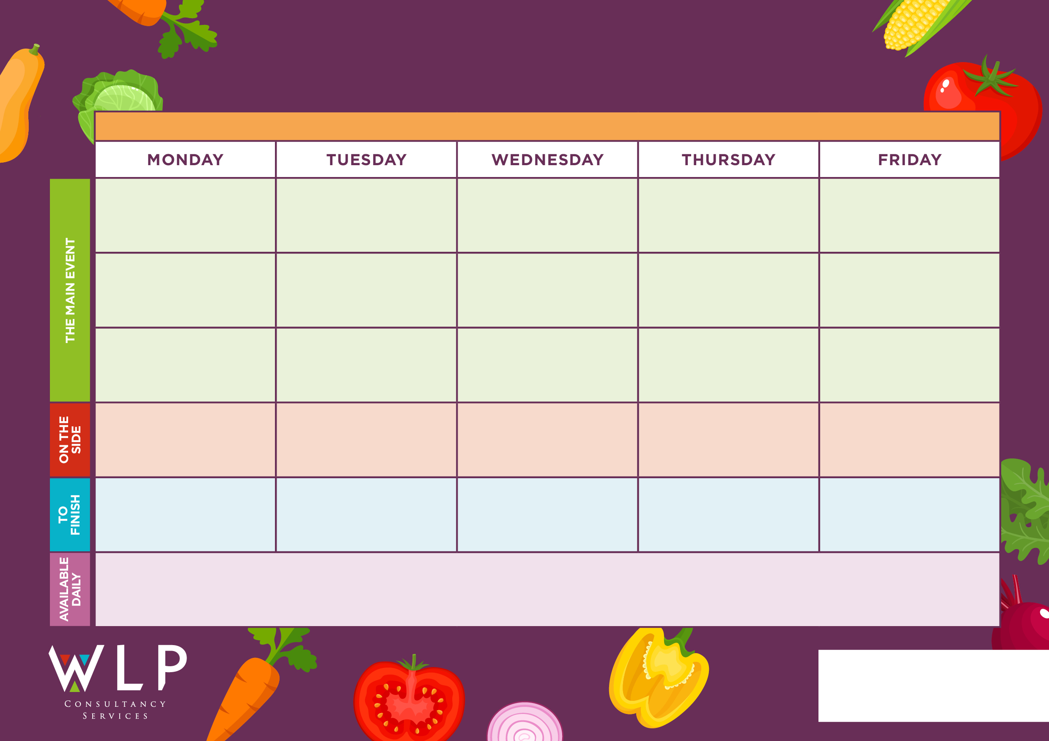
Seasonal Salad Selection & Fresh Bread

Big Breakfast,
Bacon & Pork Sausage

Potato Wedges, Couscous, Carrots, Green Beans
Roast & Creamed Potatoes, Carrots, Cabbage
Seasonal Salad Selection & Fresh Bread


Seasonal Salad Selection & Fresh Bread

Peach Meringues
RUSHBURY CE PRIMARY SCHOOL WEEK 3 W/C 27.4.2026, 18.5.2026, 8.6.2026, 29.6.2026

Pork Meatballs in Rich Tomato Sauce
Seasonal Salad Selection & Fresh Bread

Mini Waffles, Mixed Vegetables, Broccoli
Hash Browns, B/Beans, Fresh Mushrooms, Tomatoes
Cottage Pie (beef)
Freshly made bread, salad and fresh fruit, assorted yoghurts, are readily available daily.
Additional vegetarian & vegan options are available daily.

Seasonal Salad Selection & Fresh Bread

Traditional Roast Beef with Tasty Gravy
Chips, Couscous, Garden Peas, Sweetcorn

Angel Delight
Summer Fruit Tart
Cup Cakes
Battered Fish/ Vegetarian Burger
Macaroni Cheese
Quorn Fillet

Vegetable Pasties
Spaghetti Bolognaise

Ice Cream/Yoghurts
Cheese & Tomato Pasta Bake

